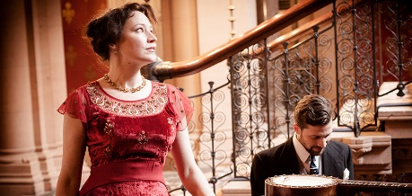
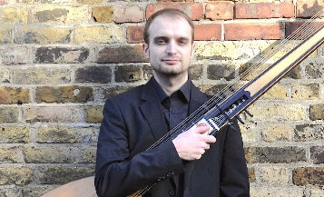
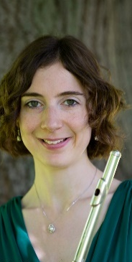

STROUD GREEN FESTIVAL PRESENTS

CELEBRATING TIME:
MUSIC DOWN THE CENTURIES
FAMILY FRIENDLY!

Wednesday 6 June, 7pm-10pm
At Holy Trinity Church, Granville Rd, N4 4EL
Pay what you can:
donations to Tottenham Refugee Alliance

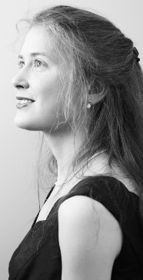
Featuring: local choirs The Stapleton Singers & Crouch End Singers; young artists Zara Jealous (flute), Chloe Lam (soprano), Mozartini Duo and local folk singer Sally Davies (Davies & Daughters); festival artists Marion Bettsworth (organ), Clare Norburn (soprano), Irena Henderson (cello), Patricia Hammond (mezzo) and Matt Redman (multi-instrumentalist).

Enjoy a sneak preview from our World of Jane Austen programme (Event 15).

Come and sing the Hallelujah Chorus at 10pm!

Book: https://stroudgreenfestival18.eventbrite.co.uk/

STROUD GREEN FESTIVAL PRESENTS

CELEBRATING TIME:
MUSIC DOWN THE CENTURIES
FAMILY FRIENDLY!

Wednesday 6 June, 7pm-10pm
At Holy Trinity Church, Granville Rd, N4 4EL
Pay what you can:
donations to Tottenham Refugee Alliance

Featuring: local choirs The Stapleton Singers & Crouch End Singers; young artists Zara Jealous (flute), Chloe Lam (soprano), Mozartini Duo and local folk singer Sally Davies (Davies & Daughters); festival artists Marion Bettsworth (organ), Clare Norburn (soprano), Irena Henderson (cello), Patricia Hammond (mezzo) and Matt Redman (multi-instrumentalist).

Enjoy a sneak preview from our World of Jane Austen programme (Event 15).

Come and sing the Hallelujah Chorus at 10pm!
Book:
https://stroudgreenfe
stival18.eventbrite.co.uk/

The war in Syria has displaced over 12 million people - 5 million of those outside its border and many of those are in urgent need of humanitarian assistance.
This country has a proud history of supporting refugees. However, in relation to this crisis the government has done far too little too late.
The Vulnerable Persons Resettlement Scheme is the government’s response to that crisis. It was established with the purpose of resettling 20,000 of the most vulnerable refugees by May 2020.
After a very slow start, the latest figures show that just over 10,000 refugees were settled by the end of 2017. Whether the UK’s commitment is sufficient and why it should end in 18 months time is a discussion for another time.

Community sponsorship is where a group of people form together in order to sponsor a family under the Vulnerable Person’s Resettlement Scheme.

That’s what the Tottenham Refugee Alliance is. We are a non-denominational and diverse group of Haringey residents committed to providing refuge and sanctuary to refugees here in Haringey. We are part of a growing movement. There are community sponsorship schemes in Muswell Hill, Hampstead,Peckham, Herne Hill, Enfield, to name just a few.

We need to show the Home Office that:
- We can support the family financially (we need a minimum of £9,000 for two adults)
- That we have appropriate accommodation.
- That we can provide English language tuition
- That we have a plan to help the family to find schools, register with a GP, get medical treatment, open bank accounts, orientate themselves on the transport system, navigate the benefits system and that we will have a support network of people known as befrienders who can look after, help and protect the family as they settle into the area.
- Once the Home Office approves our application the UN will select and vet a family from a refugee camp, matching their needs to the accommodation that we can offer and that family can arrive here within a small number of weeks. In fact there are more families approved for resettlement in the UK than there is accommodation so there are literally families in the pipeline, now, just waiting for a suitable home to become available.
- Because of the nature of the scheme, you can be sure that your donations are going to help refugees most in need – single parents, children at risk, families with special educational or medical requirements.

It’s just one family (for now) – but with your help, for that family, a home can soon be more than just a light in the distance.

Thank you.

And thank you Stroud Green Festival

…………………………………………………..
Thank you to all performers for an uplifting and joyous event.

Our organisation is grouped into:
Fundraising
Accommodation
Welfare
Education and training
Communications
The core committee

As I mentioned earlier. Our job is not just to find appropriate accommodation but to provide intensive support for the family once they arrive. That includes furnishing accommodation, providing clothes and toys, getting school places, bank accounts, English language tuition, child care so that the parents can attend classes, registering for benefits, obtaining medical treatment, local orientation, navigating the transport system. I could go on. It’s a considerable task and one which will require us to draw upon the support of the whole Haringey community.

Should you be interested in joining one of our groups, or would just like to be on our mailing list, there are volunteer lists at the back of the hall.

If you can speak Arabic or you are a landlord, we would particularly like to hear from you.

Our contact details are on the list or on our website: “Tottenham Refugees.org.uk”

You can also follow us on Twitter @tottrefugees.

Thank you all.

