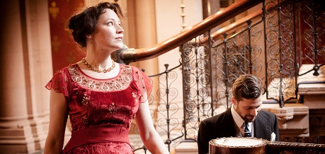
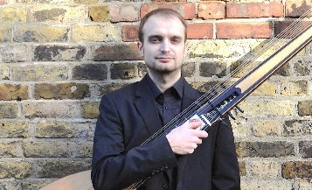
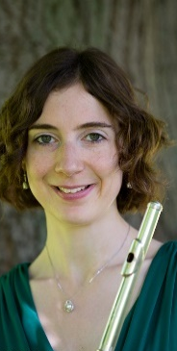

STROUD GREEN FESTIVAL PRESENTS

CELEBRATING TIME:
MUSIC DOWN THE CENTURIES
FAMILY FRIENDLY!

Wednesday 6 June, 7pm-10pm
At Holy Trinity Church, Granville Rd, N4 4EL
Pay what you can:
donations to Tottenham Refugee Alliance

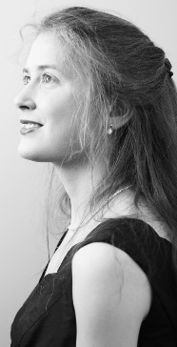
Featuring: local choirs The Stapleton Singers & Crouch End Singers; young artists Zara Jealous (flute), Chloe Lam (soprano), Mozartini Duo and local folk singer Sally Davies (Davies & Daughters); festival artists Marion Bettsworth (organ), Clare Norburn (soprano), Irena Henderson (cello), Patricia Hammond (mezzo) and Matt Redman (multi-instrumentalist).

Enjoy a sneak preview from our World of Jane Austen programme (Event 15).

Come and sing the Hallelujah Chorus at 10pm!

Book: https://stroudgreenfestival18.eventbrite.co.uk/

STROUD GREEN FESTIVAL PRESENTS

CELEBRATING TIME:
MUSIC DOWN THE CENTURIES
FAMILY FRIENDLY!

Wednesday 6 June, 7pm-10pm
At Holy Trinity Church, Granville Rd, N4 4EL
Pay what you can:
donations to Tottenham Refugee Alliance

Featuring: local choirs The Stapleton Singers & Crouch End Singers; young artists Zara Jealous (flute), Chloe Lam (soprano), Mozartini Duo and local folk singer Sally Davies (Davies & Daughters); festival artists Marion Bettsworth (organ), Clare Norburn (soprano), Irena Henderson (cello), Patricia Hammond (mezzo) and Matt Redman (multi-instrumentalist).

Enjoy a sneak preview from our World of Jane Austen programme (Event 15).

Come and sing the Hallelujah Chorus at 10pm!
Book:
https://stroudgreenfe
stival18.eventbrite.co.uk/

It’s just one family – but for that family with your help. A home can soon be more than just a light in the distance.

Thank you.

